**CSE523 Machine Learning**

**Prof. Mehul Raval**

# **Stress Detection**

**Weekly Report**

**Date: 01-04-2023**

| **Name** | **Enrolment Number** |
| --- | --- |
| Mohsinali Vijapura | AU2040080 |
| Manan Vadaliya | AU2040264 |
| Pruthviraj Dodiya | AU2040175 |
| Mitsu Sojitra | AU2040157 |

**Task performed this week:**

* Explored different feature extraction techniques such as Bag of Words, TF-IDF, and Word Embeddings to convert raw text data into numeric vectors.
* 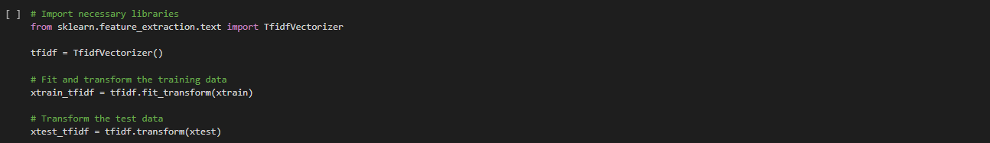
* Dimensionality reduction using PCA
* 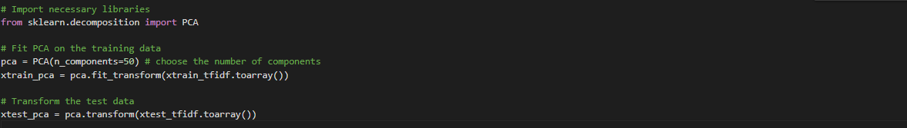
* Evaluating our model performance using different accuracy score like F1 and plotting confusion matrix .

**Challenges and Solutions**

* Working on improving the data quality and also with the data scalability
* We might Utilize sampling techniques to reduce the size of the data set while maintaining its representativeness.
* Utilize dimensionality reduction techniques like Principal Component Analysis (PCA) to reduce the size of the data set while retaining its important features.

**Task to perform end in next week**

* We are planning to implement Gradient boost and XG score algorithms on our dataset as they’re know to perform better on large sized datasets, and then evaluate their performance.